# CS 255 Business Requirements Document Template

Complete this template by replacing the bracketed text with the relevant information.

This template lays out all the different sections that you need to complete for Project One. Each section has guiding questions to prompt your thinking. These questions are meant to guide your initial responses to each area. You are encouraged to go beyond these questions using what you have learned in your readings. You will need to continually reference the interview transcript as you work to make sure that you are addressing your client’s needs. There is no required length for the final document. Instead, the goal is to complete each section based on your client’s needs.

**Tip:** You should respond in a bulleted list for each section. This will make your thoughts easier to reference when you move into the design phase for Project Two. One starter bullet has been provided for you in each section, but you will need to add more.

## System Components and Design

### Purpose

*What is the purpose of this project? Who is the client and what do they want their system to be able to do?*

* The client, DriverPass, has come to our consulting company looking to develop a new system for driver training at their local DMV.

### System Background

*What does DriverPass want the system to do? What is the problem they want to fix? What are the different components needed for this system?*

* DriverPass wants their clients to be able to take online classes and practice test in order improve success rate at the DMV.
* They will also need the system to handle on-the-road-training if the client wishes to participate in that.
* The system should allow the client to disable driver packages if they want so no more customers can register for it.
* The system should include an interface showing online test progress, student information, photos of the driver and student, special needs, and driver feedback notes.

### Objectives and Goals

*What should this system be able to do when it is completed? What measurable tasks need to be included in the system design to achieve this?*

* The system data needs to accessible from any computer or mobile device so reports and other critical information can be accessed at any time.
* DriverPass has employees with different roles in the company, and the system should be able to identify those roles and assign proper rights to each user.
* The customers need to be able to make reservations for driving lessons with an online account; also, full schedule tracking for customers and instructors must be included.

## Requirements

### Nonfunctional Requirements

*In this section, you will detail the different nonfunctional requirements for the DriverPass system. You will need to think about the different things that the system needs to function properly.*

#### Performance Requirements

*What environments (web-based, application, etc.) does this system need to run in? How fast should the system run? How often should the system be updated?*

* The system should run in a web-based application.
* The system must be capable of storing large amounts of user data and multimedia data (for lessons); this includes photos, videos, and downloadable files.

Rationale: The performance requirements capture the aspects of system such as storage requirements and running environments. For an online system, it is important the system operates in a web-based application to ensure interoperability. Since there will be large file types associated with online lessons and test, the backend server needs to be able to handle large amounts of data and deliver it quickly.

#### Platform Constraints

*What platforms (Windows, Unix, etc.) should the system run on? Does the back end require any tools, such as a database, to support this application?*

* The system should run a web-based platform that is compatible with Windows, MacOS, Unix, Android, and iOS.
* The system database should be online based as well, with a platform such as MongoDB and SQL.

Rationale: The client has specified that the system be online based to maintain compatibility with any OS their customers might be using. With an optimal database such as MongoDB, scaling of the databases to include the new processes should be a relatively easy task (if built properly) due to sharding of data zones by MongoDB (MongoDB 2020).

#### Accuracy and Precision

*How will you distinguish between different users?* *Is the input case-sensitive? When should the system inform the admin of a problem?*

* The usernames should not be case sensitive, but passwords should; this gives precision to the authentication system.
* A JavaScript action should send an alert popup or email informing administration of things such as locked out users and interruptions in system service.
* The system will have distinct access roles distinguishing users between students, admin, and IT. The IT officer should have the ability to change or modify these roles.

Rationale: Accuracy and precision detail distinctions between different types of users, what type of

input validation is necessary for different functions, and the types of situations where an admin would need to be notified. In this case, IT needs to informed of any user account lockout so they can investigate if a password reset is warranted.

#### Adaptability

*Can you make changes to the user (add/remove/modify) without changing code? How will the system adapt to platform updates? What type of access does the IT admin need?*

* The system should allow the IT officer to add, remove or modify users without changing the code.
* Planned system updates, patches and support must occur without service disruption. I f student is completing a quiz or submitting work the data cannot become lost or corrupted by an interruption to the server.
* IT admin needs full access to the system to modify these users or change roles.

Rationale: The client specified they want their IT officer to maintain the system, modify et, etcetera. Any updates to the system should result in no downtime so any student working on a lesson or quiz experiences zero downtime. By using a linked SQL database for user information, the IT officer can make changes to this database without changing the code.

#### Security

*What is required for the user to log in? How can you secure the connection or the data exchange between the client and the server? What should happen to the account if there is a “brute force” hacking attempt? What happens if the user forgets their password?*

* The system needs to require a username (e.g email address) and password for users to log in.
* System security should allow for three failed login attempts before locking the user’s account. This will require a reset from a system admin.
* The client’s IT officer should have full access rights to the system so they can reset passwords or block access to terminated employees.
* To secure the connection between clients and the server, an SSL protocol should be implemented by the owner’s IT officer to encrypt and authenticate the data being sent.

Note: SSL refers to the secure sockets layer protocol, similar to HTTP.

Rationale: Security and authentication is paramount to any system running optimally, and ensuring the correct users can access the system. Three attempts for a “brute force” hack is a standard implementation for requiring a forced reset. Since the system is hosted in an online environment, software security features should be considered to protect client and user information; these options include a hashing algorithm for authentication and an SSL protocol.

### Functional Requirements

*Using the information from the scenario, think about the different functions the system needs to provide. Each of your bullets should start with “The system shall . . .” For example, one functional requirement might be, “The system shall validate user credentials when logging in.”*

* The system shall validate user credentials (username and password) when logging in.
* The system shall be connected to the DMV database.
* The system shall allow users to make reservations for driving lessons.
* The system shall track user reservations, cancellations, and modifications.
* The system shall display the user interface to allow customers access to the various services and admin to make necessary modifications.

Rationale: Functional requirements discuss what the system does. The client has specified users need to be able to access online tests, lessons, and driving reservations after logging in with set credentials. The system must also track who makes reservations, cancellations, and modifications for administrative purposes. Connection to the DMV database is also crucial so the business can maintain their compliance with DMV standards.

### User Interface

*What are the needs of the interface? Who are the different users for this interface? What will each user need to be able to do through the interface? How will the user interact with the interface (mobile, browser, etc.)?*

* The different users of the interface include the IT officer, administrators, and customers (students).
* The student users should see a main page with the company logo, online test progress, information (name, address, phone number, etc.), driver notes, special needs, driving instructor photo, and student photo.
* The IT officer needs access to a separate navigation bar for modification tools such as add or remove users.
* The online test progress should show the tests the customer has completed or in-progress. It can show statistics such as test name, time taken, score, and status.
* The system should modify/resize the user interface to fit on mobile devices (smart phones and tablets).
* The system should have a separate page (complimented by hyperlinked buttons) to allow students to schedule driving lessons or sign up for new tests.

Rationale: The user interface is the general layout of how the online page(s) will look. These will have various buttons or graphics (powered JavaScript and CSS) to deliver vital information or functionality to the user. Since the system is being designed to be compatible with most operating systems and devices, it should incorporate Flexbox contingencies to allow mobile device users full access to the features they need.

### Assumptions

*What things were not specifically addressed in your design above? What assumptions are you making in your design about the users or the technology they have?*

* Users have access to a stable internet connection.
* Electricity is available at the users’ location.
* Each user has access to a device running Windows, Unix, MacOS, iOS, or Android.

Rationale: Assumptions are specifications being assumed about the system design. The functionality of the system depends on the user and the server having access to electricity and internet; without these things, the online learning system would not work. These are reasonable assumptions; we just want to make sure we capture them.

### Limitations

*Any system you build will naturally have limitations. What limitations do you see in your system design? What limitations do you have as far as resources, time, budget, or technology?*

* The system will not function if an internet connection is not present.
* The system will not function if electricity is lost to the users’ device or the central server.
* The system will need to be completed by a team of five people.

Rationale: These limitations describe things the system cannot function without. Due to the system being a web-based application, a steady supply of electricity and internet connection is necessary for users to access the system. Based on the interview transcript the system will need to complete by a team of five people in the tentative timeline described below.

### Gantt Chart

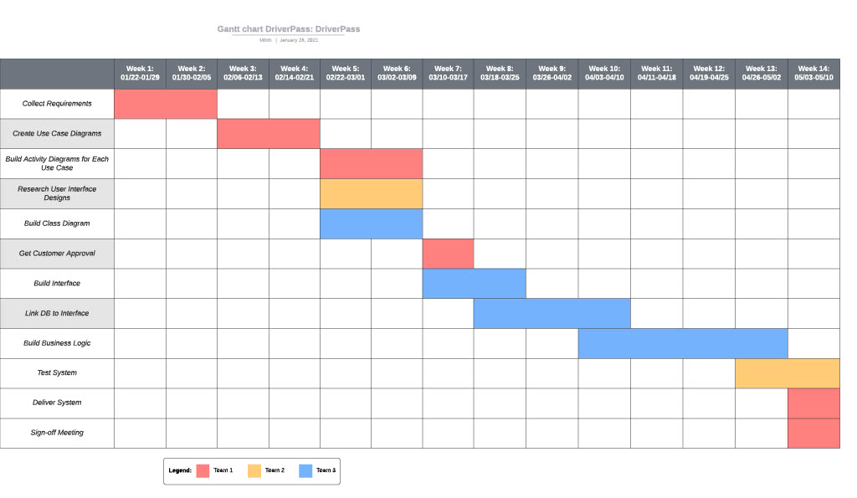

Works Cited:

MongoDB, INC. 2020. “Introduction to MongoDB”. https://docs.mongodb.com/manual/introduction/